

Future Technologies Industry Cluster
College of Vocational Education
Associate Degree in Information Technology AD006
COSC 2383 Advanced Networking 2
Task1a PT 12.5.13 Extra Questions
ANSWER SHEET
Semester 1 2023
This extra assessment task is worth 6%
Name: Vu Nguyen
Student number s4010423

Instructions.

Your points score for this task will be scaled to an assessment score out of 6
The ask tests your ability to understand and correctly use commands you covered in class labs. These questions relate to the topology in the pka lab PT 12.5.13, shown below
It is suggested that you complete the work on the pka file, to 100%, before attempting this task.
This task is open book so you are encouraged to look up commands from internet sites to help you, if necessary.
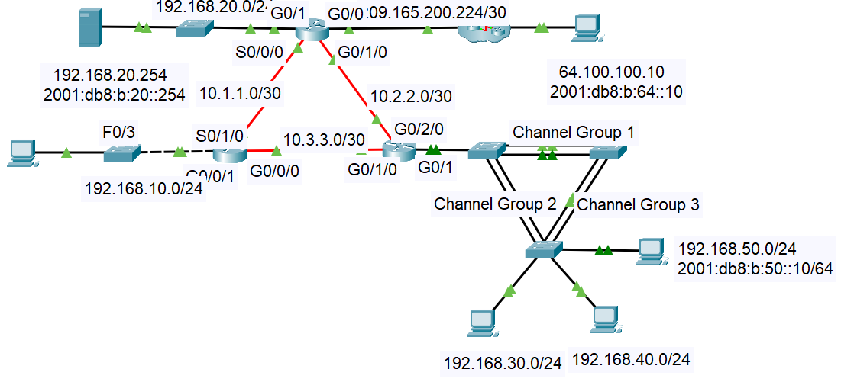
Start by writing your name and student number on this document above.
Then, rename this file with your Name_Student ID (e.g. JOHN_1234567 EAT IVR Extn)

For each task in this document, just write the commands needed. You do not need to configure the packet tracer file with these commands.

Task 1 Switchport Port Security, Etherchannel, SPAN
( Points 3+1+2+3 = 9 )
- Use internet resources to find the commands to answer this Task 1 A
On S5, configure static port security for the port connected to the TFTP server.
The port security aging timer is to be set at 2 hours
- On S2, for etherchannel, load balance based on destination ip address
- Currently the frames from vlan 30 on S4 that are headed to R3 go directly from S4 to S2. On S4, modify an STP cost value that the vlan 30 frames will go to R3 via S3.
Task 1 Be careful to paste the commands under the correct heading

A On S5, static port security for the port connected to the TFTP server
The port security aging timer is to be set at 2 hours
!On S5
int fa0/1

switchport mode access
switchport port-security
switchport port-security maximum 1
switchport port-security mac-address sticky
switchport port-security violation shutdown
switchport port-security aging time 120
B S2 load balance based on destination ip address
!On S2
interface port-channel1
port-channel load-balance src-dst-ip

C Configure S4 int Po2 with a port cost so that the vlan 30 frames will go to R3 via S3.
!On S4
Int po2
spanning-tree vlan 30 cost 200

D Write commands for SPAN on S4; frames coming from PC2 on S4’s fa0/5
Vlan 420

monitor session 1 source interface fa0/5
monitor session 1 destination vlan 420

- Frames coming from PC2 (on S4’s fa0/5) are to be sent to a server that is on S3 (the server is not shown on the PT file) Write down the SPAN commands needed on S4 only, using vlan 420

Task 2 NAT, ipv4 dhcp ( Points 2+1+1+1+1= 6 )

- Write the appropriate NAT or PAT command so that….
an outside user (e.g. at the host 64.100.100.10) may tftp (port 69) to the tftp server using the public address 209.165.200.227.

- show ip nat statistics on R2 reveals that the number of misses is increasing regularly but the number of hits remains constant. Suggest a possible cause of the problem.
(Hint: the class lab PT Review Dynamic NAT, PAT v2 covered this concept)

- Modify the named ACL on R2, so that the routers R1 and R3 cannot use the NAT service when attempting to ping any internet devices
Note: because it is a named ACL, you should write the easiest method to modify it
(Hint: When R1 uses the internet it uses the source IP address of 10.1.1.1.
When R3 uses the internet it uses the source IP address of 10.2.2.2
- Cisco phones will soon be added to the R1 LAN on a new VLAN 140. When that happens, a ndew dhcp pool on R1 will be configured for the VLAN140 network.
What dhcp configuration command must be included in a dhcp pool for VLAN140 so that the phones will receive the address of the tftp server?

Task 2 Be careful to paste the commands under the correct heading

A NAT or PAT command to allow tftp to an inside server
! On R2
interface G0/0
ip nat outside
interface G0/1
ip nat inside
ip nat inside source static udp 192.168.20.254 69 209.165.200.227 69
B Probable cause of the ping failures for pings from PC1 to the outside host
Probable cause could be insufficient NAT
C R1 and R3 can’t use NAT => Modify the named ACL; use the simplest method;
! On R2
conf t
ip access-list extended NAT-ACL
deny ip host 10.1.1.1 any
deny ip host 10.2.2.2 any
permit ip any any
exit
ip nat inside source list NAT-ACL interface GigabitEthernet0/0 overload
D DHCP pool command on R1 so that phones get tftp server address
! On R1
Ip dhcp pool VLAN40
network 192.168.140.0 255.255.255.0
default-router 192.168.140.1
option 150 ip 192.168.20.254

Task 3 ipv6 dhcp ( Points 1+4= 5)

Don’t test this task on the PT file – just write the answers below

- Configure R3 so that PC2 may receive an ipv6 address using SLAAC
- Configure the tftp server on the R2 LAN so that the tftp server provides stateless ipv6 dhcp services to local clients.
Call the pool R2_Stateless. Use the domain name of cisco2.com and use an appropriate DNS server address
Configure the R2 gi0/1 interface with appropriate commands.Us
Task 3 Be careful to paste the commands under the correct heading

A PC2 needs to use SLAAC to obtain an ipv6 address from R3
! On R3
ipv6 unicast-routing
interface g0/1
ipv6 address 2001:db8:b:30::1/64
ipv6 nd other-config-flag
no shutdown

B Stateless ipv6 dhcp using the server on the R2 LAN
Show server settings(with a screenshot) and any other settings

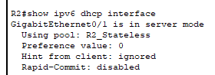

!R2
Int gi0/1
ipv6 address 2001:db8:b:30::1/64
ipv6 nd other-config-flag

ipv6 dhcp pool R2_Stateless
dns-server 2001:db8:b:20::2
domain-name cisco2.com
ipv6 dhcp server R2_Stateless

